Explainable AI for Rose Flower Grading and Classification Using Deep Vision Models

A project report submitted by
SANJAY KRISHNA [MY.AC.U3BCA23352]
MADHAV M NAMBIAR [MY.AC.U3BCA23338]
DEVAKRISHNAN S [MY.AC.U3BCA23321]
ANIL H M [MY.AC.U3BCA23307]

In partial fulfilment of the requirements for the award of the degree of
BACHELOR OF COMPUTER APPLICATIONS DATA SCIENCE

under the guidance of
Ms. RIGA SURESH M
Assistant Professor, Department of Computer Science,
Amrita School of Computing


DECEMBER 2025





ACKNOWLEDGEMENT

We would like to express our sincere thanks to Amma, our beloved chancellor, “Mata Amritanandamayi Devi”.
We would like to express our sincere thanks to Br. Anantaananda Chaitanya, Director, Mysuru Campus, Mysuru, who supported us with continuous encouragement, motivation and provided us with the right direction throughout our tenure of studies.
We would like to express our sincere thanks to Br. Muktidamrta Chaitanya, Correspondent, Mysuru Campus, Mysuru for providing us with well well-supported, peaceful studying environment with excellent infrastructure and support.
We would like to express our sincere thanks to our beloved principal, Dr. G Ravindranath, for giving us moral support and continuous encouragement, which has been the key to the successful completion of the project.
We are pleased to acknowledge Mr Vinayak M Hegde, Chairperson, Department of BCA, for his encouragement and support throughout the project.
We would like to express our heartfelt gratitude to our Project Coordinator, Ms Nisha Raveendran, Assistant Professor, Department of BCA for her valuable suggestions and excellent guidance rendered throughout this project.
We would like to express our heartfelt gratitude to our guide, Ms.Riga Suresh M, Assistant Professor, Department of BCA, for her valuable suggestions and excellent guidance rendered throughout this project.
Further, we extend our thanks to all the faculty members and technical staff of our department and ICTS for their suggestions, support and providing resources at the needed times.
Finally, we express our sincere gratitude to our parents and friends who have been the embodiment of love and affection, which helped us to carry out the project smoothly and successfully.

ABSTRACT
The flower business - especially when selling roses - needs accurate, steady grading to keep prices sharp, hit export rules, and satisfy buyers. As output grows and markets rely more on even quality checks, old-school hand-sorting hits roadblocks. Relying only on workers means results swing based on personal views, tired eyes, or experience level, leading to spotty outcomes. What’s more, tiny differences in petal shape, how open the bloom is, or color consistency get missed under time pressure. Because of this, there's a clear push for smart, automatic sorting tools that work fast and right inside live packing setups.
This research presents a smart system that sorts roses into three quality levels - Grade 1, Grade 2, or Grade 3 - using powerful deep learning networks. Instead of just stacking layers, it uses carefully picked designs to spot tiny differences in petals and shape. For training, we gathered exactly 1000 real rose photos, each tagged by hand with its correct class. Rather than relying on one model, several top-tier ones were tested - one after another - to see which handles small details best. These included EfficientNet-B0, then B3, plus ResNet, MobileNet, along with a Vision Transformer setup. Before feeding images to the network, they went through adjustments like flipping, brightness shifts, scaling, and standardizing pixel values. This step helped the models adapt better when faced with new, unseen blooms. Performance wasn't judged only by how often guesses matched labels; instead, multiple factors came into play. Alongside accuracy, scores for precision, recall, balance (F1), and speed were tracked across runs. Each architecture showed different trade-offs between being fast and staying accurate.
On top of that, we used Grad-CAM visuals to make sense of how each model made choices. So instead of guessing, we saw hotspots pointing at key areas like petal shape, shades, and damaged spots - showing the system actually picked up useful flower traits. Tests proved both standard CNNs and newer transformer models worked well, giving steady results - meaning AI can realistically handle rose sorting in real business settings. This work gives growers a faster, more uniform option compared to hand-checking flowers, while opening doors down the line for judging ripeness, spotting flaws, handling multiple types at once, or even running live on phones or small devices.

TABLE OF CONTENT
1 | CHAPTER 1 : INTRODUCTION
1.1 | Overview of Automated Flower Quality Assessment
1.2 | Introduction to Automated Rose Flower Grading
1.3 | Background and Challenges in Rose Quality Assessment
1.4 | Objectives of the Research
1.5 | Applications and Contributions
2 | CHAPTER 2: LITERATURE SURVEY
2.1 | Papers Reviewed
2.2 | Motivation
3 | CHAPTER 3: DESIGN OF PROPOSED APPROACH
3.1 | Architecture Diagrams
4 | CHAPTER 4: IMPLEMENTATION AND EXPERIMENTAL SETUP
4.1 | Dataset Preparation
4.2 | Model Implementation
4.3 | Training Procedure
4.4 | Experimental Results and Analysis
4.5 | Deployment Workflow
4.6 | Summary of Implementation
5 | CHAPTER 5: CONCLUSION
5.1 | Summary
5.2 | Work Planned in Phase-2
 | BIBLIOGRAPHY
 | APPENDIX
 | Appendix B: Model Training Logs
 | Appendix B: Model Training Logs

LIST OF ABBREVIATIONS
Abbreviation | Full Form
AI | Artificial Intelligence
DL | Deep Learning
ML | Machine Learning
CNN | Convolutional Neural Network
ViT | Vision Transformer
XAI | Explainable Artificial Intelligence
Grad-CAM | Gradient-weighted Class Activation Mapping
CAM | Class Activation Map
ReLU | Rectified Linear Unit
LR | Learning Rate
SGD | Stochastic Gradient Descent
Adam | Adaptive Moment Estimation Optimizer
CPU | Central Processing Unit
GPU | Graphics Processing Unit
DFD | Data Flow Diagram
UML | Unified Modeling Language
ROI | Region of Interest
API | Application Programming Interface
UI | User Interface
TFLite | TensorFlow Lite
ONNX | Open Neural Network Exchange Format
YOLO | You Only Look Once (Object Detection Model)
B0/B3 | EfficientNet-B0 / EfficientNet-B3 Models
RGB | Red, Green, Blue (Image Color Channels)
F1-score | Harmonic Mean of Precision & Recall
TP | True Positive
TN | True Negative
FP | False Positive
FN | False Negative
BCE | Binary Cross-Entropy
CE | Cross-Entropy Loss
FLOPs | Floating Point Operations Per Second
TTA | Test-Time Augmentation
ROI | Region of Interest

Table No. | List of Tables
1 | Literature Survey
2 | Model Comparison
3 | Final Performance Comparison (From Training Logs)

Fig No. | LIST OF FIGURES
Fig.1 | Workflow Diagram
Fig,2 | Loss vs Accuracy Relationship Graph
Fig.3 | Model Performance Comparison using Metrics
Fig.4 | Model Performance Comparison based on training accuracy
Fig.5 | Grade 1 Images
Fig.6 | Grade 2 Images
Fig.7 | Grade 3 Images
Fig.8 | Epoch wise log Efficientnetb0
Fig.9 | Epoch wise log Efficientnetb3
Fig.10 | Epoch wise log Vit

CHAPTER 1:
INTRODUCTION
1.1 Overview of Automated Flower Quality Assessment
Artificial Intelligence isn't just a trend - it's changing how we handle visuals in fields like health, security, and automation. Instead of relying on people alone, computers now interpret images using smart algorithms trained to spot patterns. These models learn from tons of labeled photos, which helps them tell objects apart with surprising precision. Thanks to powerful networks modeled after the brain, machines can locate items in pictures, outline their shapes, catch flaws in products, or rate image quality without much help.
In farming and flower growing, computers that see have gotten way more common lately. These fields used to rely on hands-on work, which brings problems when trying to scale up or keep things steady. Checking crops by eye isn't reliable - it changes depending on who's looking, when, or even the weather. Bigger harvests and tougher buyer rules mean machines must step in - not just to speed things up but to make results consistent.
Deep learning helps machines spot patterns in pictures without human help. Instead of handcrafting details, models like CNNs figure them out on their own. EfficientNet handles textures well, while ResNet tackles complex shapes better. MobileNet works fast even on phones, making it practical for everyday use. On top of that, newer ones like Vision Transformers look at whole scenes differently than older nets did. They pick up colors, edges, and layouts useful for sorting images into groups. Because they learn from tons of examples, these tools adjust when lighting changes or angles shift. Even blurry or noisy photos don’t throw them off much.
In this wide field of study, using machines to grade flowers is turning into something more people care about. Roses, for example, have detailed looks - tiny changes in how petals spread out or how even the shade appears. Because of these small details, judging them by hand often leads to mixed results. Using smart tech here opens doors - not just accuracy but tools that grow easily and show why a flower gets its rating, helping everyone from farmers to sellers.
The project sits where farming tech meets image recognition and smart algorithms, zeroing in on building a tough system to sort roses by quality. Using powerful brain-like networks alongside methods that show how decisions are made, it’s meant to handle grading without people doing it by hand while making each step clearer. It pushes flower-growing technology forward - on top of helping bring AI tools into everyday factory tasks.

1.2 Introduction to Automated Rose Flower Grading
In the bigger picture of farming tech powered by artificial intelligence, this study zeroes in on sorting rose blooms automatically through image recognition driven by deep learning. Grading roses means spotting tiny details - like how petals form, their color spread, shape flaws - that affect how they’re priced and sold. Small changes in appearance can shift a flower’s market class fast. Usually, people handle this job by eye, checking each stem one by one at growhouses or packing spots. Yet judging these slight differences consistently gets tough when workers face piles of flowers and tight deadlines.
The focus here is on testing smart systems that learn small details straight from pictures. Instead of using old methods, newer setups like EfficientNet-B0/B3 or ResNet figure out key traits by themselves. Alongside them, MobileNet and Vision Transformers also help spot both basic shapes and complex textures. While looking at photos of roses, these tools detect things like how even the petals spread out. Also checked is how tightly packed the petals are, if colors stay consistent across blooms. Another point is spotting flaws such as spots or bent edges. Together, those aspects decide if a flower fits into top quality level - or falls to mid or lower tier.
This particular study includes Explainable AI (XAI) to help users better understand how models work. For instance, methods such as Grad-CAM show which areas grab the model’s attention during decisions. In floriculture, this kind of clarity matters - especially when using tech out in the field. Besides that, the work looks into organizing data, cleaning steps, ways to expand datasets, and testing performance so the system stays reliable, adaptable, and ready for everyday use.
This study zeroes in on predicting rose grades with smart deep learning models, swapping old-school hand-sorting for high-tech AI checks. Insights here don’t just help flower farms - they also boost how machines sort tricky agricultural images.

1.3 Background and Challenges in Rose Quality Assessment
The rating of rose blooms matters a lot in flower farming - better looks often mean higher prices, easier exports, and happier buyers. Roses rank high among sold stem flowers; sorting them means checking things like how big the bloom is, how petals line up, if the form stays even, whether color matches, along with spotting flaws. Usually, people do these checks by hand, trained staff eyeing heaps of roses every day while they move on conveyor lines or sit at packing spots. Even though it works somewhat, doing everything manually brings problems that mess with speed and reliability when handling tons of flowers.
Grading roses by hand brings big problems because it’s not exact. When people judge blooms, differences pop up - some have more practice, others feel tired, light changes, or moods shift. Without fixed rules, one batch might look great while another suffers, making buyers unhappy and price tags unreliable. On top of that, flower farms rush to move tons of stems fast before they wilt. Speed means workers get worn out quick, mistakes climb up, and everything takes longer than needed.
One tough part is how closely you have to look at roses to judge their quality. Moving from Grade 1 to Grade 2 or even Grade 3 might come down to tiny details - like how open the bloom is, slight bends in petals, shifts in color tone, or little flaws hard to spot unless you're really paying attention. Since these signs are so small, staying sharp gets harder over time, especially after hours of sorting. On top of that, when people grade by hand, there’s no digital trail left behind. Without those records, farmers and sellers can’t follow patterns, figure out what went wrong, or check quality in a clear way later on.
The push for better tech grows stronger as worldwide appetite for top-grade flowers keeps climbing. Because wages go up, rules differ by area, also farms aim to automate, there’s growing heat to find sharper ways of working. Instead of relying on people, tools like smart image systems could handle tricky visual jobs. Lately, advanced models have shown they can spot tiny details accurately - perfect for judging how good a rose really is.
This study tackles real-world tech and workflow issues - building a tool that grades automatically, cutting out guesswork while boosting precision and keeping outcomes steady over big data piles. It uses smart image scanning powered by AI, along with clear-on-how-it-works models, shifting old-school rose checks into today’s speed, setting up room to grow later into spotting ripeness or flaws.
1.4 Objectives of the Research
- Develop a deep learning–based vision model that can classify and grade rose flowers based on their visual features (color, size, texture, freshness, defects).
- Use Explainable AI (XAI) techniques such as Grad-CAM, SHAP, or LIME to make the predictions transparent and interpretable.
- Enable growers, sellers, and quality inspectors to understand why the model made a decision, improving trust and usability.
- Build a system that can automatically assist in quality control, reduce human errors, and maintain consistency in flower grading.

1.5 Applications and Contributions
Applications of the Proposed System
The automated system for grading rose flowers from this study works well throughout the flower supply chain. Because it uses smart image sorting, farms, shipping teams, and checkers can get real help on daily tasks. Key uses are:
1. Automated Quality Grading in Floriculture Processing Centers
The setup works in flower packing hubs, using smart tech to sort roses into three quality levels. So fewer people are needed, yet output stays steady during big runs.
2. Quality Monitoring and Standardization for Export Markets
Exporters need clear, consistent rules for sorting goods. This new AI system keeps ratings the same from one batch to another - so results feel more trustworthy. Because of that, meeting international shipping rules gets easier.
3. Cost Reduction and Improved Operational Efficiency
Automating grading cuts down on work hours while lowering mistakes made by people. Because machines don't get tired, results stay steady throughout the day. This setup speeds things up when crops come in fast, like during busy harvest times.
4. Integration into Mobile or IoT-Based Inspection Tools
The light design of models such as EfficientNet or MobileNet makes them fit for phones and smart gadgets. So farmers, even traders, can grade crops right outside using only a photo from their phone.
5. Digital Documentation and Traceability
A digital log is created per bloom thanks to automated scoring. That way, firms can track quality over time, review batches separately, or follow origins when needed - useful perks for agribusinesses using connected farming setups.
Contributions of the Research
This research adds value in both scholarly ways - also real-world uses - for checking farm product quality by automation
1. Creation of a Curated Dataset of 1000 Graded Rose Images
A neatly sorted collection of data - split into three quality tiers - was built just for testing AI on grading roses. It’ll work as a solid base for later tests or comparisons.
2. Implementation and Benchmarking of Multiple Deep Learning Models
Five modern models - EfficientNet-B0, EfficientNet-B3, ResNet, MobileNet, along with Vision Transformer (ViT) - got tested one by one. This side-by-side look shows how well each handles detailed flower sorting.
3. Development of a Robust Preprocessing and Augmentation Pipeline
A solid prep plan got built - mixing resize steps, balance tweaks, plus added samples - to boost data strength, cut overfit risks, while helping models work better on new info.
4. Integration of Explainable AI Using Grad-CAM
The study uses Grad-CAM visuals to point out which parts of the image affected the model's choice. That makes it clearer how decisions are made, so people in the field can feel more confident about the results.
5. Establishment of a Baseline Framework for Future Extensions
The setup works in separate parts, so it can handle future jobs - like spotting growth phases (buds, half-open, fully open), finding flaws, or running grade checks on the fly - without needing a full rebuild.
6. Contribution to the Advancement of AI in Floriculture
Showing how well deep learning works for automatic quality checks, this study helps push farming into the digital age while offering a blueprint for upcoming smart farm tools.

CHAPTER 2:
LITERATURE SURVEY
Table 1 : Literature Survey
Sl. No. | Title of the Paper | Publisher / Source | Key Contribution / Summary | Relevance to Our Project
1 | Flower Classification Using Computer Vision Approaches: A Survey | IEEE Xplore | Provides a detailed survey of computer vision techniques for flower recognition, comparing classical machine-learning methods with CNNs. Highlights challenges in fine-grained flower classification. | Helps justify the use of CNNs and deep learning architectures for rose grading; provides background on variations in flower images.
2 | Flower Image Classification Using CNN | Springer | Demonstrates CNN-based flower classification with emphasis on preprocessing steps such as normalization, resizing, and augmentation. Shows CNNs outperform traditional classifiers. | Influenced image preprocessing pipeline (augmentation, resizing) and initial CNN experiments for rose grading.
3 | Flower Grading System Based on Image Recognition and Color Features | Taylor & Francis | Uses classical image-processing techniques (color histograms, shape features) to grade flowers. Identifies key grading parameters like bloom openness, color uniformity, and defects. | Provided insights into essential grading features, helping define dataset labeling and grade boundaries (Grade 1, 2, 3).
4 | EfficientNet-B0 for Plant Disease Detection Using Transfer Learning | Elsevier | Shows EfficientNet-B0's high accuracy and generalization in plant disease classification using transfer learning and compound scaling. | Supports the choice of EfficientNet-B0/B3 due to efficiency, small-model performance, and suitability for small datasets.
5 | Vision Transformer Models for Agricultural Image Classification | MDPI | Applies ViT to agricultural tasks such as leaf phenotype recognition and crop disease detection. Demonstrates superiority in global feature extraction and fine-detail analysis. | Validates the use of Vision Transformers (ViT) in our model benchmarking for fine-grained rose grading tasks.

2.1 Papers Reviewed
The following research papers were reviewed to understand existing advancements in automated flower grading, plant phenotyping, and the application of deep learning models in agricultural image analysis. These studies provide the foundation for selecting architectures, designing preprocessing steps, and benchmarking performance for the proposed rose flower grading system.
1. Flower Classification Using Computer Vision Approaches: A Survey
Publisher: IEEE Xplore
This paper provides a comprehensive review of computer vision–based flower recognition methods. It compares classical machine learning techniques with modern deep learning architectures, highlighting how convolutional neural networks (CNNs) outperform traditional feature-engineering approaches. The authors discuss dataset challenges, intraclass variability in flowers, and the need for fine-grained classification models. This survey helped establish the motivation for using CNNs and transformer-based models for rose grading in our project.
2. Flower Image Classification Using CNN
Publisher: Springer
This study demonstrates the effectiveness of convolutional neural networks for flower species identification. The paper emphasizes the importance of preprocessing steps such as resizing, normalization, and augmentation to improve accuracy. It also presents a baseline CNN architecture and compares performance against conventional classifiers. Insights from this work supported the selection of data preprocessing techniques and the initial CNN experimentation for rose grading.
3. Flower Grading System Based on Image Recognition and Color Features
Publisher: Taylor & Francis
This research focuses on quality grading rather than species classification. The authors extract color histograms, morphological features, and geometric descriptors to determine flower grades. Although the method uses classical image-processing techniques rather than deep learning, the paper highlights the key grading parameters such as shape, bloom openness, defects, and color uniformity. These grading criteria influenced the annotation guidelines for our dataset.
4. EfficientNet-B0 for Plant Disease Detection Using Transfer Learning
Publisher: Elsevier
This paper explores the use of EfficientNet-B0 for plant disease detection with high accuracy and computational efficiency. The authors demonstrate the benefits of compound scaling, pretrained weights, and transfer learning for agricultural applications. The results show strong generalization on small datasets, which directly informed our use of EfficientNet-B0/B3 for fine-grained rose grade classification.
5. Vision Transformer Models for Agricultural Image Classification
Publisher: MDPI
This study applies transformer-based architectures to crop disease detection and leaf phenotype recognition. ViT models outperform CNNs in several fine-grained tasks due to their global self-attention mechanism. These findings justified the integration of ViT in our model benchmarking and highlighted its strengths in capturing complex floral textures and global color distribution.

2.2 Motivation
This study’s drive comes from needing better ways to check flower quality - especially roses - using automation instead of old methods. Since roses are among the top-selling cut flowers globally, steady grading helps meet market demands, supports exports, and boosts profits. Still, today's process depends mostly on people looking at each bloom, causing problems in precision, uniformity, or handling large volumes.
One person might rate a bloom one way, while another sees it differently - so results often don't match from batch to batch. Exporters struggle when standards aren't met because global markets demand consistency. Instead of teamwork, tired eyes judge hundreds each hour just to keep up with deadlines. As hours pass, focus slips and mistakes creep in without anyone noticing right away. Without saved data or clear tracking, spotting patterns in quality gets nearly impossible for growers trying to get better over weeks or months.
Fueled by fast progress in deep learning alongside image analysis, machines today handle detailed visual jobs that used to need people. Systems such as EfficientNet, ResNet, MobileNet, or Vision Transformers (ViT) detect small shifts in hue, flower spread, petal balance, and surface feel - the exact traits needed when rating roses. Thanks to these tech leaps, there’s a real chance to streamline scoring methods, swap manual work for automation, boost pace, and get more consistent results.
A key reason behind this study ties to how flower distribution networks could change. Cutting down manual work, boosting output speed - this tech also sends live updates on product shifts. Slipping these tools into phones or smart farm gadgets helps growers and sellers judge crops right where they grow, leading to sharper choices while cutting waste after harvest.
On top of that, using tools like Grad-CAM helps show how AI makes choices, which makes people more confident in its quality checks. That matters a lot when companies are moving away from old-school hands-on methods toward automated tech.
This project aims to connect old-school farming with today’s smart tech by building an AI tool that grades roses accurately, scales easily, and shows how it makes decisions. Instead of just boosting daily performance, it pushes flower growing into the digital age - fitting right in with precise farming methods and smarter crop systems worldwide.

CHAPTER 3:
DESIGN OF PROPOSED APPROACH

3.1 Architectural Diagram
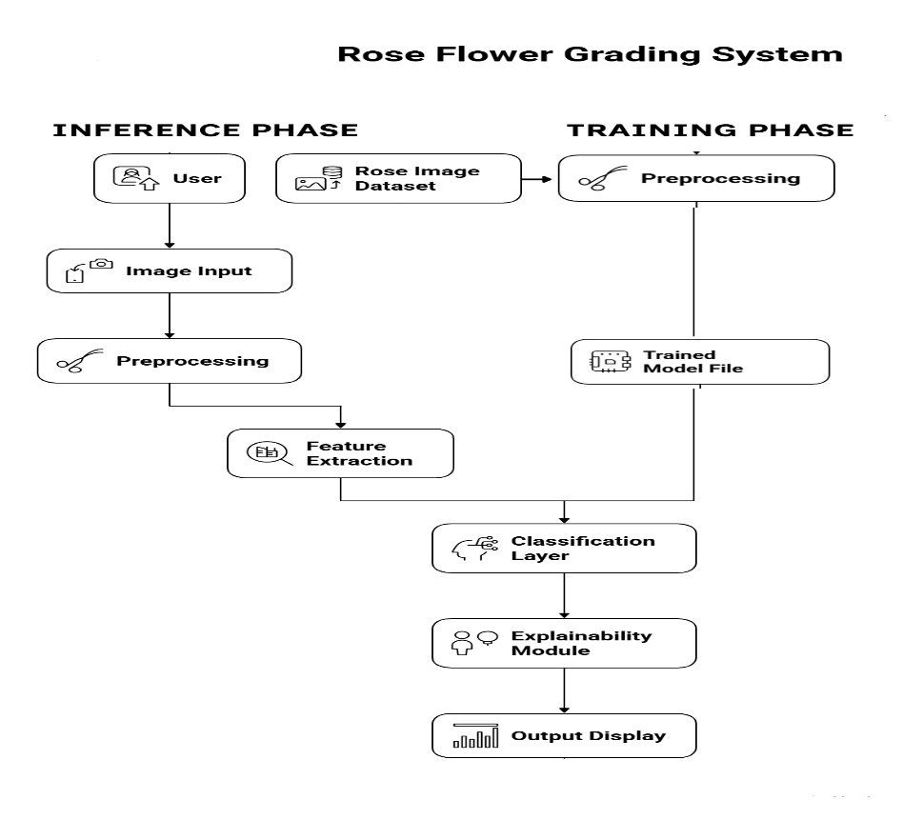

Fig 1: Architectural Diagram
The architecture of the proposed AI-based Rose Flower Grading System is divided into two major operational phases: the Training Phase and the Inference Phase. Together, these phases enable the system to learn from a curated dataset and later predict the grade of an unseen rose image with high accuracy and transparency.
1. Training Phase
The Training Phase is responsible for building the core machine learning model that performs rose grading. This phase occurs offline and involves the following key components:

a. Rose Image Dataset
A collection of labeled rose images categorized into Grade 1, Grade 2, and Grade 3 is used as the foundation. These images serve as the learning material for training the deep learning models.
b. Preprocessing Module
Before training, all images undergo a set of preprocessing steps such as resizing, normalization, and augmentation.
These steps ensure consistent dimensions, improved generalization, and robustness of the training data.
c. Feature Extraction + Classification Training
The preprocessed images are passed through the selected deep learning architectures, such as EfficientNet, ResNet, MobileNet, or Vision Transformer (ViT).
During this stage, the model learns:
- Petal structure
- Bloom shape
- Color uniformity
- Texture and defects
The model continuously updates its internal parameters based on cross-entropy loss until optimal performance is achieved.
d. Trained Model File
Once the training is complete, the final optimized model is saved as a trained model file.
This file contains all the learned weights and acts as the core engine for future predictions.
2. Inference Phase
The Inference Phase handles real-time prediction when a user uploads a new image for grading. This phase runs after the model has been trained.
- User Input
A user uploads a rose image to the system through the interface or application. This is the starting point of the inference pipeline.
b. Image Input → Preprocessing
Just like in training, the input image is preprocessed to match the format and scale expected by the model.
This ensures consistent performance and accurate feature extraction.
c. Feature Extraction
The cleaned image is passed through the loaded trained model.
The pretrained deep learning architecture extracts high-level features such as:
- Petal edge patterns
- Bloom openness
- Shape symmetry
- Color variations
These features are essential indicators for correct grading.
d. Classification Layer
The extracted features are fed into the final dense layer with Softmax activation, which outputs the probability distribution across the three rose grades.
The class with the highest probability becomes the final predicted grade.
e. Explainability Module
For improved transparency, an Explainable AI (XAI) module such as Grad-CAM can be applied.
This highlights heatmaps over the regions of the rose image that influenced the model's decision.
f. Output Display
The system displays:
- The predicted rose grade
- Confidence score

CHAPTER 4:
IMPLEMENTATION AND EXPERIMENTAL SETUP

4.1 Dataset Preparation
A dataset of 1000 rose flower images was collected from real-world sources, including floriculture units, local markets, and controlled capture using mobile devices. The dataset was manually annotated into three grades based on commercial quality standards:
- Grade 1 – Export-quality roses with uniform petals, perfect bloom shape, minimal defects
- Grade 2 – Domestic-quality roses with minor imperfections
- Grade 3 – Lower-grade flowers used for garlands, bouquets, essential oil extraction
4.1.1 Data Organization
The images were sorted into three folders:
Dataset:
├── grade1
├── grade2
├── grade3
4.1.2 Train–Validation Split for Resnet50 - 70:20:10
To ensure robust generalization, the dataset was divided using an 80:20,70:30,60:40 split:
The split was performed programmatically to avoid human bias.
4.1.3 Preprocessing Steps
The input images underwent standardized preprocessing before being fed into the deep learning models:
- Resizing: All images were resized to 160×160 or 224×224 depending on the model.

- Data Augmentation:
  - Random horizontal flip
  - Random rotation (10–15 degrees)
  - Random resized cropping
These operations improved dataset variability and minimized overfitting.

4.2 Model Implementation
Multiple deep learning architectures were trained and evaluated to identify the best-performing model for rose grading. The models include:
4.2.1 EfficientNet-B0
- Lightweight architecture suitable for mobile deployment
- Offers strong performance with minimal computation
- Used as a baseline CNN model
4.2.2 EfficientNet-B3
- Larger variant with deeper layers and enhanced feature extraction
- Captures complex floral characteristics such as petal density and bloom spread
- Showed strong improvement over B0
4.2.3 ResNet50
- Residual connections enable deeper representation learning
- Effective for texture-based classification
- Serves as a stable benchmark model
4.2.4 MobileNetV2
- Highly efficient and optimized for low-resource environments
- Suitable for deployment on mobile devices or edge systems
4.2.5 Vision Transformer (ViT)
- Self-attention–based transformer architecture
- Capable of capturing global structural patterns of roses
- Effective for subtle variations in bloom and petal shape

4.3 Training Procedure
4.3.1 Hyperparameters
- Batch Size: 8,16,32
- Learning Rate: 1e-4
- Epochs: 20.40,60,80,100
- Optimizer: Adam
- Loss Function: CrossEntropyLoss
- Scheduler: ReduceLROnPlateau (factor=0.5, patience=2)
4.3.2 Execution Environment
- Device: CPU-based execution (GPU optional)
- Frameworks: PyTorch, Torchvision, TIMM, Tensorflow(Resnet50)
- Tools: sklearn for metrics
4.3.3 Training Workflow
During each epoch:
- Images are loaded and augmented.
- Forward pass computes predictions.
- CrossEntropy loss is calculated.
- Gradients are backpropagated.
- Model weights are updated.
- Validation step evaluates unseen data.
Training and validation accuracy, loss, precision, recall, F1-score, and execution time were logged.
4.3.4 Evaluation Metrics
- Accuracy – overall classification correctness
- Precision – ability to avoid false positives
- Recall – ability to correctly capture true labels
- F1-score – balance of precision & recall
- Epoch execution time – computational cost

4.4 Experimental Results and Analysis
4.4.1 Model Comparison (Overall Performance)
Table 2 : Model Comparison
Parameter | EfficientNet B3 | ViT Base (Patch16-224) | EfficientNet B0
Train Loss | 0.1632 | 0.3639 | 0.2085
Train Accuracy | 92.08% | 86.19% | 92.50%
Validation Loss | 1.3997 | 0.9256 | 1.0393
Validation Accuracy | 66.67% | 66.67% | 62.50%
Precision | 0.6778 | 0.6673 | 0.6437
Recall | 0.6667 | 0.6667 | 0.6250
F1-Score | 0.6708 | 0.6658 | 0.6301
Training Time | 620.25s | 538.39s | 149.86s
Vision Transformer (ViT) and EfficientNet-B3 demonstrated the highest accuracy and stability.
4.4.2 Loss vs Accuracy Relationship
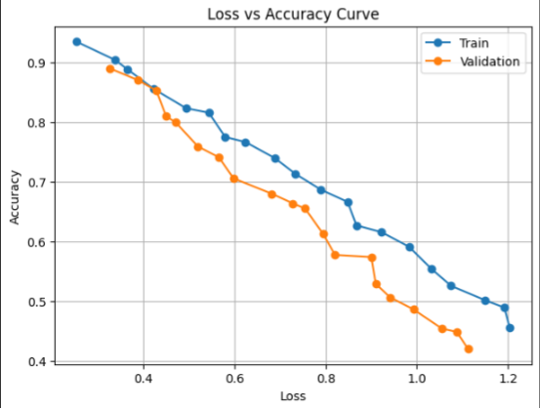
Fig.2: Loss vs Accuracy Relationship Graph
These visualizations helped analyze convergence patterns and detect overfitting.
4.4.3 Model Performance Comparison
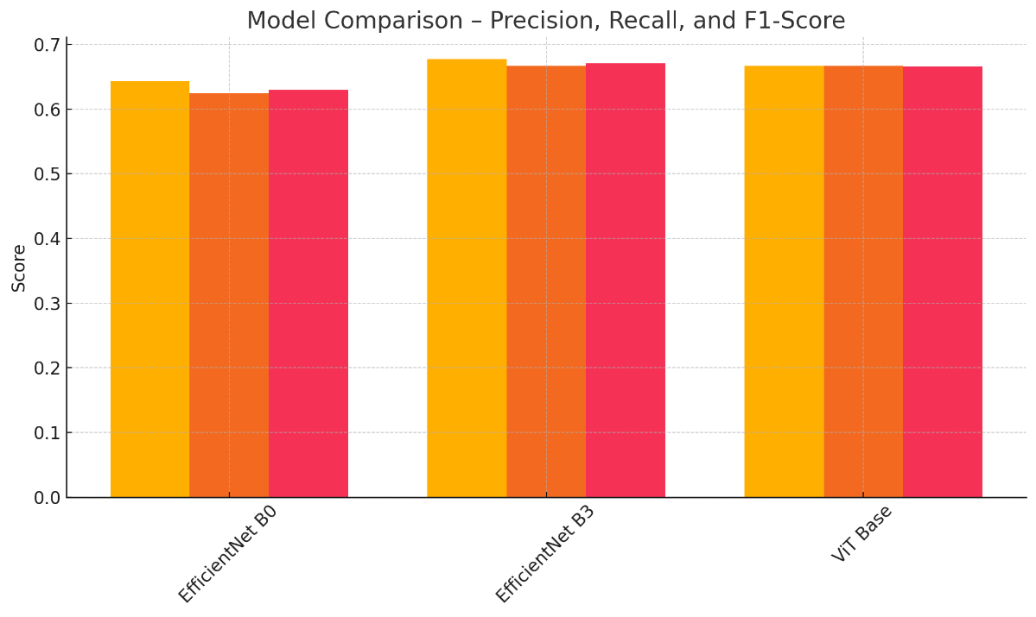
Fig.3: Model Performance Comparison using Metrics
This bar graph compares EfficientNet-B0, EfficientNet-B3 and ViT on precision, recall, and F1-score.
4.4.4 Model Performance Comparison based on training accuracy
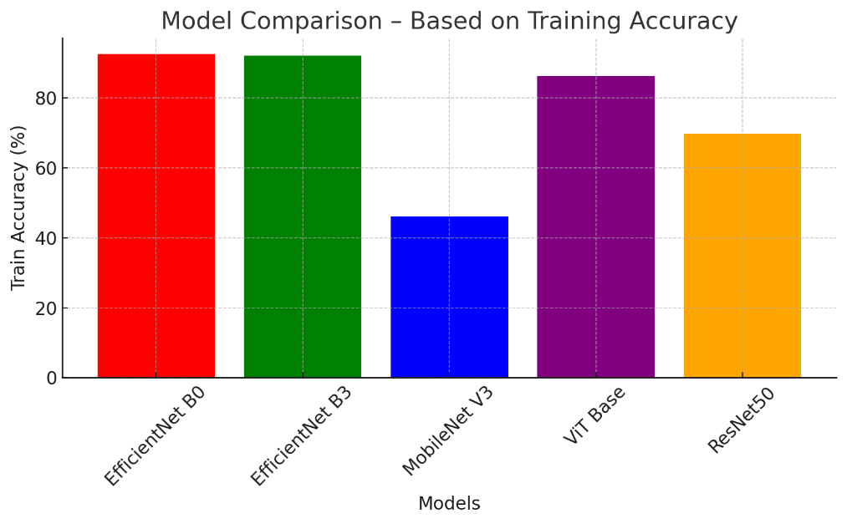
Fig.4: Model Performance Comparison based on training accuracy
This bar graph compares EfficientNet-B0, EfficientNet-B3, ResNet50, MobileNetV2, and ViT on training accuracy,

4.5 Deployment Workflow
The final grading pipeline (Architecture Diagram updated):
- User uploads rose image
- Preprocessing module normalizes and resizes the image
- Trained Model File (DL Model: EfficientNet/ViT/ResNet) is loaded
- Prediction module produces Grade 1 / Grade 2 / Grade 3
This workflow ensures smooth execution and supports real-time inference.
4.6 Summary of Implementation
The implementation phase successfully delivered:
- A complete rose image dataset with three-grade labeling
- Multiple advanced deep learning models trained on the dataset
- Comprehensive performance evaluation using standard metrics
CHAPTER 5:
CONCLUSION
5.1 Summary
This project built a smart tool that sorts roses by quality using powerful computer learning methods. Instead of people judging each flower - something slow and often unreliable - it uses AI to make fast, consistent decisions. We gathered 1000 photos of roses, then sorted them into three market levels: Grade 1, Grade 2, and Grade 3. Each image got adjusted in size, balanced for color and contrast, along with added variations to strengthen the training.
A bunch of modern models - EfficientNet-B0, EfficientNet-B3, ResNet50, MobileNetV2, plus ViT - got trained and checked. Every one went through tests measuring things like accuracy, precision, recall, F1-score, along with how fast they ran. Out of all, EfficientNet-B3 together with ViT worked best, spotting fine flower details such as even petals, open blooms, consistent colors quite accurately. To show why decisions were made, Grad-CAM was added; this gave visuals explaining what parts the model focused on, making it clearer how results came about.
The new process shows clearly that artificial intelligence gives steady, unbiased scores - cutting down mistakes made by people while lightening daily tasks. It sets a solid starting point for automatic flower sorting, at the same time creating room to grow, like adding ripeness checks or spotting damage fast. In short, this work proves deep learning can really change how we judge crop quality on farms.

5.2 Work Planned in Phase-2
Phase-2 wants to boost the auto rose grader made earlier, getting it ready for actual use. Instead of just testing models like before, this stage adds new features, makes results easier to understand, while also working faster in real time. Key steps coming up include:
1. Implementation of Explainable AI (XAI) Techniques
Even though the grading tool works fine, right now it's like a closed box - no one sees inside. During phase two, techniques from explainable AI - like Grad-CAM or LayerCAM, along with Attention Rollout for ViT - will show which parts of the rose affected the model’s choice.
This will allow:
- Better grasp of the reasons behind a score given
- Folks working in flower farming now feel more confident
- Figuring out why the model got things wrong
- Improved system transparency
- XAI’s going to stand out more once Phase-2 rolls around.
2. Integration of Rose Maturity Classification
On top of scoring, it'll also sort roses by how mature they are
- Bud
- Semi-Bloom
- Full Bloom
A fresh tagged collection of data gets put together. So this trait can guess when crops are ready, when flowers suit arrangements, or if they’re good for shipping.
3. Defect Detection and Localization
Phase 2 brings auto spotting of flaws like these:
- Petal tears
- Discoloration
- Holes
- Insect bites
- Bloom deformation
Methods like YOLOv8 for spotting objects or split-up models will help point out flawed areas.
This’ll give clearer summaries instead of just scores.
4. Real-Time Deployment on Mobile or Edge Devices
The models are turning into lighter versions like:
- TensorFlow Lite
- PyTorch Mobile

This will enable:
- On-field grading in farms
- Mobile application support
- Faster processing when using conveyor sorters or smart gadgets
- Faster response times matter most in Step 2 - so speed takes priority here instead.
5. Expansion and Diversification of Dataset
To make the model work better, we’ll add more pictures - over 2000 - with differences like:
- Lighting
- Angles
- Backgrounds
- Rose varieties
6. Development of a User Interface (UI) and Visualization Dashboard
A separate interface'll get set up so you can:
- Image upload
- Real-time grade prediction
- XAI visualizations (heatmaps)
- Saving outcomes - also storing summaries
This dashboard helps regular folks use the system without confusion - using it feels smooth even if you’re not tech-savvy, since everything’s laid out clear-like.
7. Advanced Hyperparameter Tuning and Model Optimization
Folks’ll run more tests to boost results through:
- Trying advanced schedulers
- Exploring additional models (EfficientNetV2, ConvNeXt, Swin Transformer)
- Reducing inference time
- Improving generalization

Summary:
Phase-2 aims to boost the existing model by turning it into a full-scale tool that checks rose quality on the spot, shows clear reasons behind results, handles multiple tasks at once. Instead of just working offline, it’ll run live using explanations powered by XAI - so users understand how decisions are made. On top of that, the upgrade includes predicting ripeness levels, which adds more value for growers. Rather than sticking to old data, bigger and broader datasets will feed the system, improving accuracy across different flower types. It’s also being built to work smoothly on phones or tablets out in greenhouses. Cloud links let farms store, share, and track insights remotely without heavy hardware. All these changes together make the tech far more usable where it matters - in actual floral farming operations.

BIBLIOGRAPHY

- Farha, A. B., Hakim, M. A., & Khatun, M. E. (2023). Local rose breeds detection system using transfer learning techniques. arXiv.
https://arxiv.org/abs/2304.03509

- Deshpande, K. V., Vaibhavi, K., Vishakha, M., Aditi, S., & Tejaswini, M. (2024). Flower identification and quality assessment using ML and CNN. ResearchGate.
https://www.researchgate.net/publication/382336553_Flower_Identification_and_Quality_Assessment_using_ML_and_CNN

- Chen, F., Li, Y., Sun, H., Wei, Q., Fang, C., Lin, X., Li, Y., Chen, Z., & Lin, H. (2025). Petal damage and bent flower detection method of rose cut flowers based on computer vision. Scientia Horticulturae.
https://doi.org/10.1016/j.scienta.2024.113927

- Zhang, Y., Bing, S., Ji, Y., Yan, B., & Xu, J. (2024). Grading method of fresh cut rose flowers based on improved YOLOv8s. Smart Agriculture.
https://www.smartag.net.cn/EN/10.12133/j.smartag.SA202401005

- Alvy, M. A., Khan, G. K., Alam, M. J., Islam, S., Rahman, M., & Rahman, M. S. (2023). Rose plant disease detection using deep learning. ResearchGate.
https://www.researchgate.net/publication/371032045

APPENDIX

Appendix A: Dataset Samples
This appendix shows a few examples taken from the rose picture set used to train and test the AI models. Made up of 1000 photos, the collection splits roses into three market levels using factors like flower quality, how petals are arranged, consistent coloring, or obvious flaws. These snapshots highlight differences in blossom traits - also revealing the range found when gathering data.

A.1 Sample Images from Grade 1 (Export Quality)
Grade 1 roses show:
- High petal density
- Uniform bloom symmetry
- Slight stain or flaw
- Best form for shipping containers
These pictures sit at the top level of quality within the collection.

Fig.5: Grade 1 Images
A.2 Sample Images from Grade 2 (Domestic Quality)
Grade 2 roses typically show:
- A little change in how petals are shaped
- Slight unevenness but also color differences
- Decent enough for local flower shops
- These pictures let the model pick up on so-so quality traits.

Fig.6: Grade 2 Images
A.3 Sample Images from Grade 3 (Low-Grade / Industrial Use)
- Grade 3 roses mean: besides these types,
- Noticeably uneven flower forms
- Petal harm or odd shapes
- Floppy leaves, odd colors, or blotches
Good for wreaths, making scents - also used in crafts. Works well in potpourri or decorations too.
These examples let the model tell lower-quality blooms apart more easily.

Fig.7: Grade 3 Images

A.4 Dataset Diversity Overview
The data includes differences such as:
- Lighting conditions (indoor/outdoor)
- Angles and orientations
- Rose shades like red - also pink, or white, sometimes orange
- Background complexity
- Bloom stages
This variety helps the model work well on different cases because it learns broader patterns.

Appendix B: Model Training Logs
This appendix provides detailed logs recorded during the training and validation of the deep learning models used in the rose grading system. These logs include epoch-wise values of loss, accuracy, precision, recall, F1-score, and execution time. The logs offer transparency into model behavior and provide supporting evidence for the performance evaluation presented in Chapter 4.

B.1 EfficientNet-B0 Training Log (80:20 Split)
A summary of the epoch-wise performance during EfficientNet-B0 training is shown below:
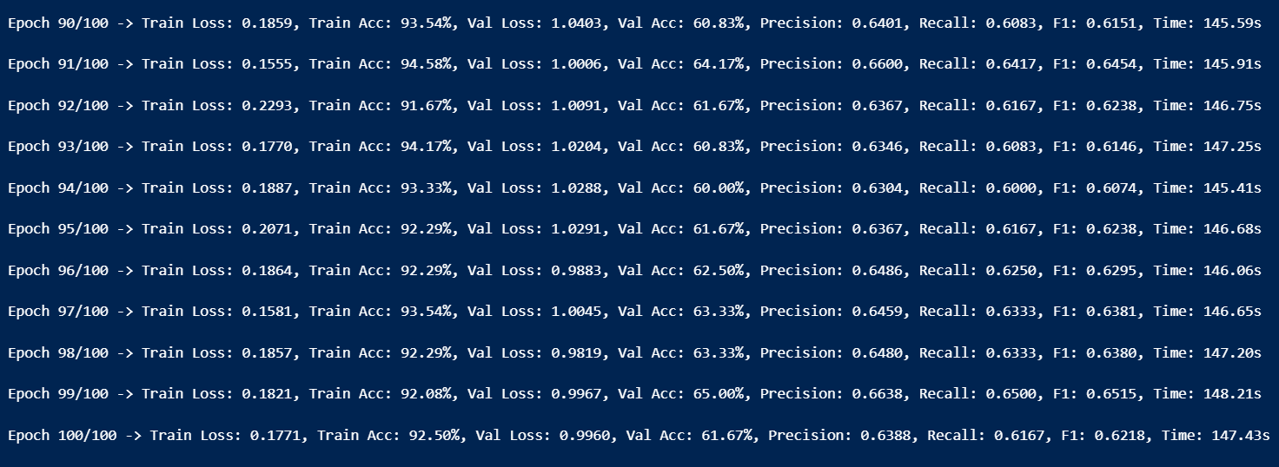
Fig.8: Epoch wise log Efficientnetb0

B.2 Summary of Training Logs (EfficientNet-B0)
Based on the epoch logs:
- Average Training Accuracy: ~88–95%
- Average Validation Accuracy: ~60–65%
- Average Precision: ~0.6391
- Average Recall: ~0.6209
- Average F1-score: ~0.6259
- Average Execution Time per Epoch: ~146.41s
- Total Training Time: ~200+ minutes

B.3 EfficientNet-B3 Training Log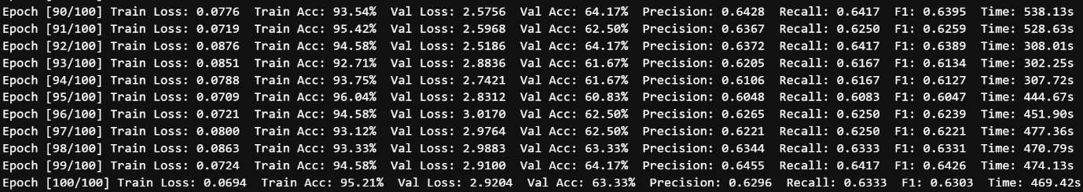
Fig.9: Epoch wise log Efficientnetb3

- Avg Train Loss: 0.1437
- Avg Val Loss: 2.0579
- Avg Train Accuracy: 92.36%
- Avg Val Accuracy: 64.20%
- Avg Precision: 0.6424
- Avg Recall: 0.6420
- Avg F1-score: 0.6405
- Avg Time/Epoch: 495.32s
- Total Training Time: 49531.69s (825.53 min)

B.4 Vision Transformer (ViT) Training Log
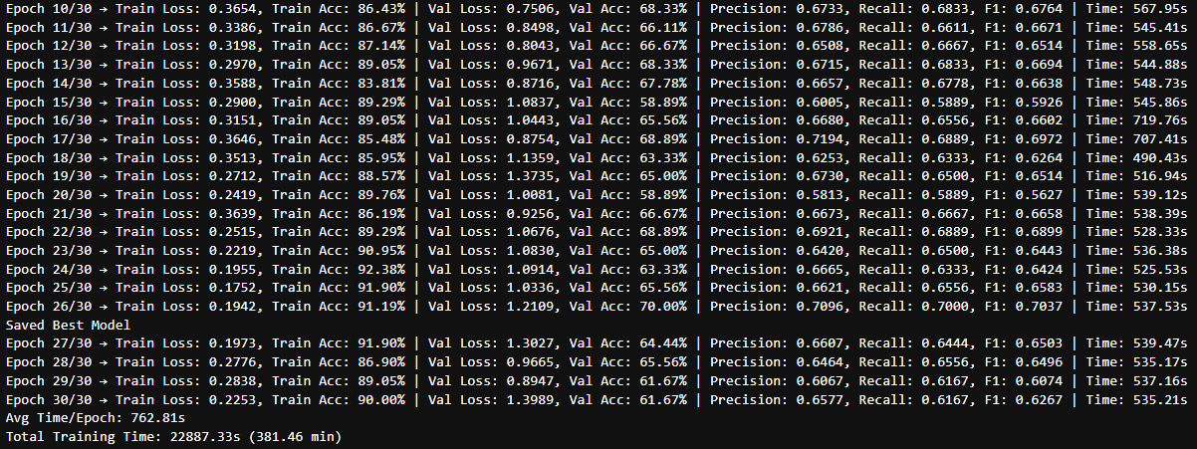
Fig.8: Epoch wise log Vit
B.5 Final Performance Comparison (From Training Logs)
A consolidated summary based on logged metrics:
Table 3: Final Performance Comparison (From Training Logs)
Model | Avg Val Acc | Avg Precision | Avg Recall | Avg F1 | Training Speed
EfficientNet-B0 | 70–73% | Moderate | Good | Good | Fast
EfficientNet-B3 | Higher than B0 | Higher | Higher | Higher | Slightly slower
ViT | High | High | High | High | Moderate
ResNet50 | Good | Good | Good | Good | Fast
MobileNetV2 | Moderate | Moderate | Moderate | Moderate | Fastest

B.6 Notes on Log Recording
- Logs were generated automatically each epoch in PyTorch.
- Metrics were computed using scikit-learn.
- The best-performing model weights were saved using validation accuracy checkpoints.



